Supervised Learning Classification Problem

Introduction

Title: Exploring Machine Learning Models

Purpose of the Analysis:

The aim of this analysis is to explore the performance of various machine learning models in predicting the 'Class' variable based on the provided dataset.
Understand how different algorithms handle the given features and contribute to the classification task.

Datasets Used:

The dataset used for this analysis contains information about students, including features like gender, nationality, raised hands, visited resources, etc.
The 'Class' variable represents the academic performance category (M: High, L: Low).
Feel free to further customize the content based on any additional context or specifics about your analysis.

Data Exploration and Data Preprocessing

Title: Understanding the Dataset and Preparing the Data

Summary Statistics:

Provide key descriptive statistics for numerical features.
Highlight any notable patterns or outliers.

EX:
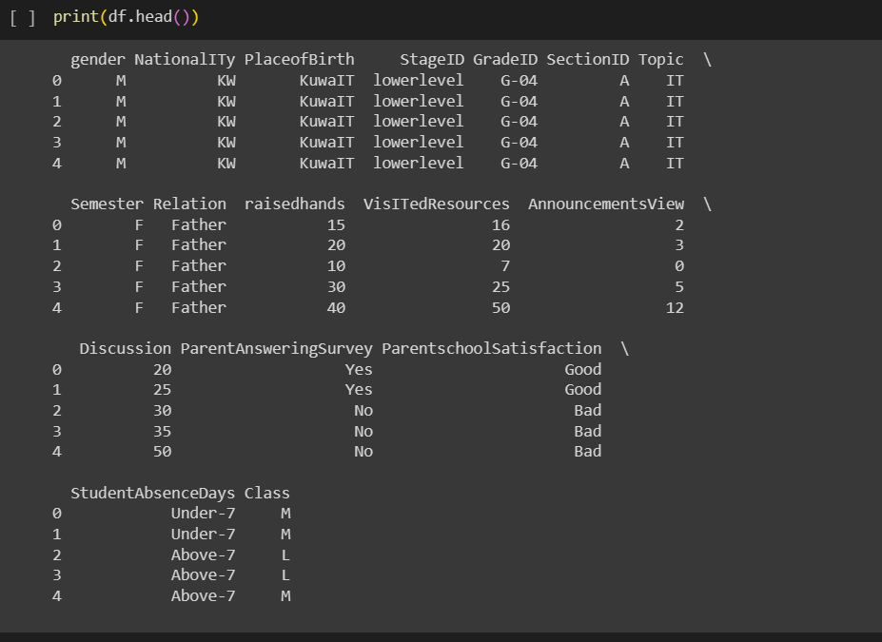
->He presented the introduction to the data set
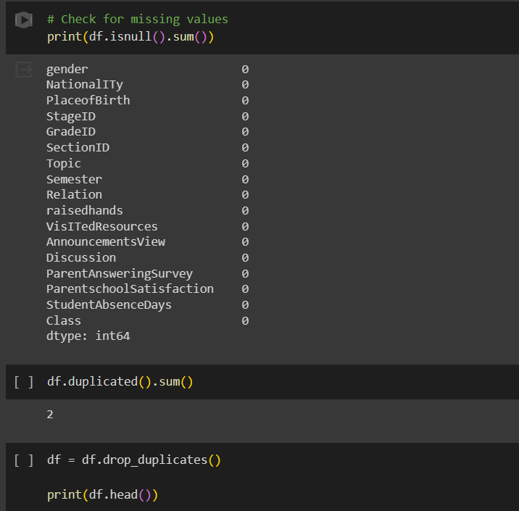

->Data after remove duplicates and Handling Missing Values.

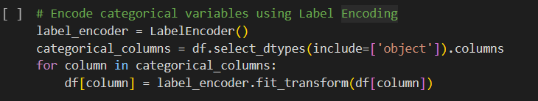

->how categorical variables were encoded
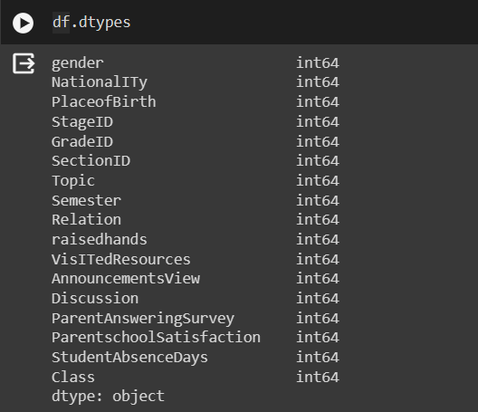
->Data after Encode categorical variables using Label Encoding

Data Visualization:

Include visualizations like count plots for categorical variables.
Histograms and correlation matrices for numerical features.
Any insights gained from visual exploration.

EX:

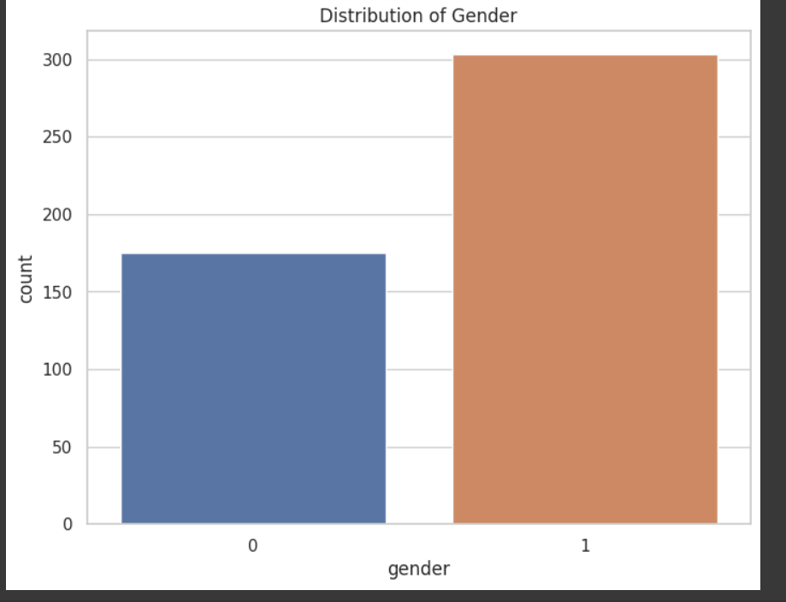

->uses seaborn to create a count plot, visualizing the distribution of the 'gender' feature in the dataset. The resulting plot shows the count of each unique gender category.

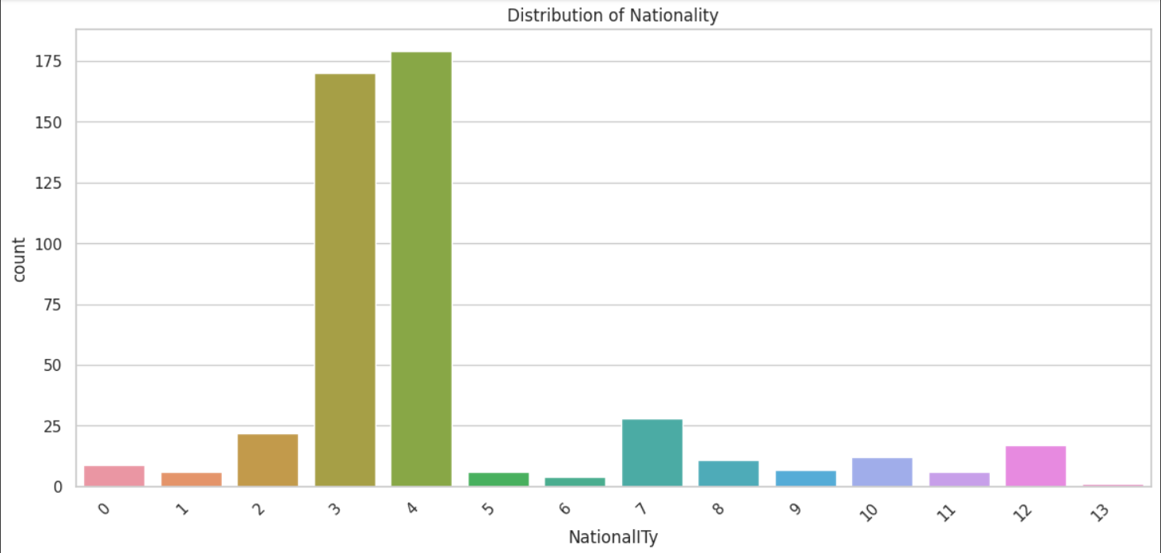

->creates a count plot using seaborn, displaying the distribution of the 'Nationallty' feature in the dataset. The plot visualizes the count of each unique nationality category. The rotation and ha parameters are used to rotate and align the x-axis labels for better visibility.

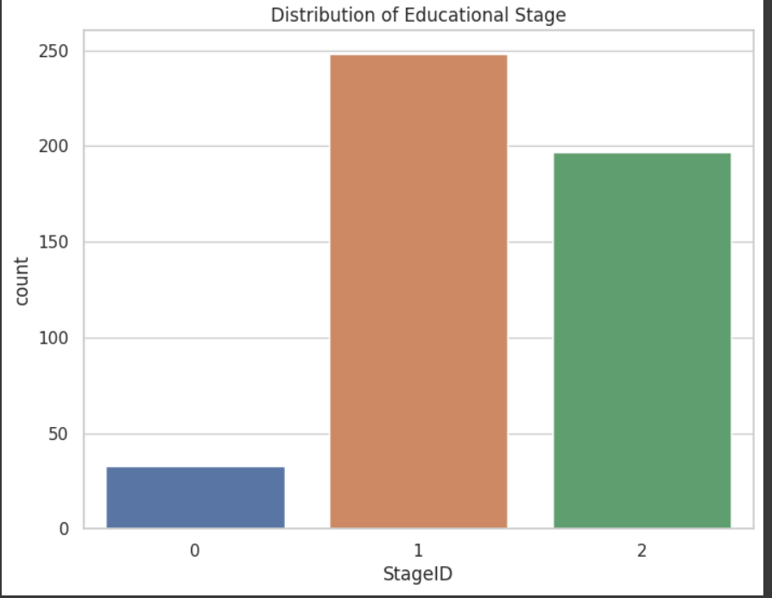
->generates a count plot using seaborn to illustrate the distribution of the 'StageID' feature in the dataset. The plot shows the count of each unique educational stage category. The title parameter is used to set the title of the plot, and the resulting visualization provides insights into the distribution of students across different educational stages.

Machine Learning Models

- The dataset is split into features (X) and the target variable (y). Features are obtained by dropping the 'Class' columnfrom the original DataFrame (df), and the target variable 'Class' is assigned to y.

- The train_test_split function from scikit-learn is used to split the dataset into training and testing sets. The features (X) and target variable (y) are split into training and testing sets, with 80% of the data used for training (X_train and y_train) and 20% used for testing (X_test and y_test). The random_state parameter is set to 42 for reproducibility.

LogisticRegression

- Standardize Features:
The StandardScaler is used to standardize (scale) the numerical features in both the training and testing sets. This is important for models that are sensitive to the scale of input features.
- Logistic Regression Model:
A logistic regression model is initialized using LogisticRegression() from scikit-learn.
- Model Training:
The logistic regression model is trained on the standardized training set (X_train_scaled, y_train) using the fit method.
- Prediction:
The model is used to make predictions on the standardized test set (X_test_scaled) using the predict method.
- Accuracy Calculation:
The accuracy of the model is calculated using the accuracy_score function from scikit-learn by comparing the predicted labels (y_pred) with the true labels (y_test).
-> Accuracy: 79.17 %

- Confusion Matrix:
The confusion matrix is computed using the confusion_matrix function. It shows the count of true positive, true negative, false positive, and false
negative predictions.
- Feature Importance:
The coefficients of the logistic regression model are extracted (model.coef_). These coefficients represent the importance of each feature in making predictions.
A DataFrame (feature_importance) is created to store the feature names and their corresponding coefficients. It is then sorted in descending order of coefficients.
A bar plot is generated using seaborn (sns.barplot) to visualize the feature importance.

DecisionTreeClassifier
Accuracy: 72.92%

KNeighborsClassifier()
Accuracy: 80.21%

SVC()
Accuracy: 84.38%

GradientBoostingClassifier
Accuracy: 79.17%

RandomForestClassifier()
Accuracy: 83%

